PROJECT NO:2

**TITLE PAGE:**

* **PROJECT TITLE: Classificationof breast cancer histology images using Convolutional Neural Networks**
* **NAME OF THE STUDENT:** **Selvakumar S**
* **DATE:**

## **Abstract:**

* Breast cancer is one of the most prevalent and life-threatening conditions in women across the globe. Early and accurate detection is of greatest significance in improving patient survival and preventing unnecessary interventions. This project, titled "Classification of breast cancer histology images using Convolutional Neural Networks" proposes to build an intelligent diagnosis system to classify Breast cancer is one of the most prevalent and life-threatening conditions in women across the globe. Early and accurate detection is of greatest significance in improving patient survival and preventing unnecessary interventions. This project, titled "Classification of breast cancer histology images using Convolutional Neural Networks" proposes to build an intelligent diagnosis system to classify histopathological images as benign or malignant using deep learning technology. Drawing upon the IDC breast cancer dataset, we built a CNN-based model, titled CancerNet, utilizing the Keras library. It was trained to learn automatically from microscopic images and achieved high accuracy in distinguishing cancerous and non-cancerous tissues. Our approach prevents manual feature engineering and demonstrates the ability of AI in making cancer diagnosis possible at an early stage. The results demonstrate the efficiency of CNNs in medical imaging tasks and establish their value in improving clinical decision-making and making advanced healthcare technology available.

### **1.Introduction:**

* The "Breast Cancer Classification using Convolutional Neural Network (CNN)" project aims at solving one of the greatest problems in medical diagnosis—early and accurate breast cancer detection. The most common and deadliest cancer among women globally is breast cancer. For women between the ages of 20 and 59, breast cancer is the leading cause of cancer-related deaths, and for those over 59, it ranks second [1]. The diagnosis and treatment of this pathology in the early stages is essential to prevent the progression of the disease and reduce its morbidity rates [2]. Breast cancer is one of the top new cases of cancer and cancer death, according to global health data. Early and precise diagnosis is not only necessary to enhance the survival rate of patients but also to avoid unnecessary treatment and health costs. In today's healthcare environment, artificial intelligence (AI) is transforming disease diagnosis and treatment. This project leverages the potential of deep learning—namely Convolutional Neural Networks (CNNs)—to label breast tissue histopathological images as malignant or benign. Such labelling is essential in helping medical experts with early detection, hence improved treatment planning and results.

**Figure 1.** Examples of microscopy image patches from the used dataset [3].

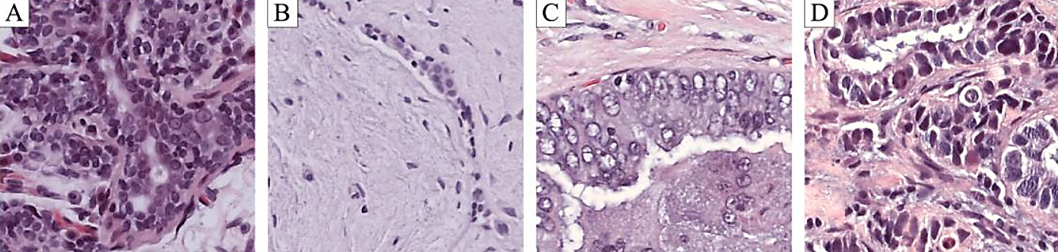

* Nuclei and cytoplasm appear purple and pinkish, respectively, due to the hematoxylin and eosin staining. **A** normal tissue; **B** benign abnormality; **C** malignant carcinoma *in situ*; **D** malignant invasive carcinoma.
* Figure 1 shows an example of patches from whole slide images stained with H&E for each of the classes mentioned. The staining enhances nuclei (purple) and cytoplasm (pinkish), as well as other structures of interest [4].

#### **Importance and objectives:**

##### **Importance of breast cancer classification with (CNN):**

1.**Early Detection of cancer saves lives:** Early detection of cancer can significantly enhance the prospects for successful treatment.

2.**Minimizing Diagnostic Burden:** Computerized microscopic image classification reduces the pathologists' workload and minimizes the risk of human error.

3.**Medical Progress:** Aligns with general objectives of advancing healthcare technology and enabling drug discovery.

##### **Objectives of breast cancer classifications with (CNN):**

1.To train a model of deep learning based on a Convolutional Neural Network (CNN) to accurately classify breast cancer histology images.

2.For training the models and testing the models using the IDC (Invasive Ductal Carcinoma) dataset.

3.To apply and develop the CNN model, CancerNet, using the Keras deep learning library.

4.To achieve improved classification performance in distinguishing malignant from benign breast cancer images.

#### **Problem we’re addressing and goal of this project:**

* Here, in this project context, you are being conceptualized as a Chief Data Scientist at a big medical corporation with cancer hospitals. Your task is to develop a smart AI system capable of identifying cancer cells from histology images much earlier than the disease is fatal. This technology has the potential to save lives and aid in the development of medicine and drug discovery.

##### **Goals of using Breast cancer classification with (CNN):**

1.**Create an AI-Powered Diagnostic Tool:** Design a Convolutional Neural Network (CNN) based deep learning model to diagnose breast cancer histopathology images and classify them as benign or malignant correctly.

2.**Use Real Medical Data:** Train and test the model using the IDC dataset of microscopic images of breast tissue so that it can be utilized in real life.

3.**Design a High-Performance CNN Architecture:** Use a custom CNN architecture, called CancerNet, based on the Keras deep learning library to learn proper features from raw images automatically without any human intervention.

4.**Improve Diagnostic Accuracy:** Improve the accuracy and efficiency of cancer diagnosis, reducing misdiagnosis and unwanted treatment for benign tumor patients.

#### **AI techniques and Methodologies:**

* The research utilizes deep learning techniques, i.e., Convolutional Neural Networks (CNNs), to address the problem of binary classifying breast cancer histopathological images. The proposed CancerNet model was validated with the Keras high-level neural network API atop the TensorFlow backend, leveraging the capability of CNNs to capture abstract features and spatial hierarchies within images*.*

**1.Data Preprocessing and Data Augmentation:**

* The data set for this project is the IDC (Invasive Ductal Carcinoma) breast cancer histopathology image data set, which consists of labeled microscopic images of benign or malignant type. Preprocessing was done on images by,

1. Resizing to a standard shape compatible with the input layer of the CNN.
2. Normalization to scale pixel intensity values to 0 to 1, beneficial for faster convergence of training.
3. Random rotation, flip, zoom, and shift data augmentation procedures were applied to artificially increase the size of the training set and enhance the resilience of the model against overfitting.

**2.CNN Architecture Design:**

* The model suggested, CancerNet, is a typical CNN configuration with a sequence of convolutional and pooling layers, and classification with fully connected layers. A few of the salient architectural components are:

1. Convolutional layers with larger filters to extract low-to-high level features.
2. ReLU (Rectified Linear Unit) activation functions for non-linearity.
3. MaxPooling layers to do spatial downsampling and feature reduction.
4. Dropout layers to avoid overfitting by shutting down neurons randomly during training.
5. Fully connected (dense) layers with a final sigmoid activation function for binary output classification.
6. **Model Training:**

* The model was trained using the binary cross-entropy loss function because it is appropriate for binary classification problems. The Adam optimizer was used because it is an adaptive learning rate optimizer and is suitable with gradient descent. The model was trained for a few epochs using mini-batch gradient descent, and training data were divided into a validation set to monitor and enhance generalization performance.

1. **Evaluation Metrics:**

* The model's performance was tested with standard classification metrics, providing an overall evaluation of its diagnostic potential:

1. **Accuracy:** Overall accuracy of the predictions.
2. **Precision:** The ratio of true positives to all predicted positives.
3. **Recall:** The proportion of true positives to all the actual positives.
4. **F1-Score:** Harmonic mean of precision and recall.
5. **Confusion Matrix**: A complete classification of prediction outcomes by class.

* These values were calculated on a held-out test set to measure the generalization performance of the CancerNet model that was trained.

1. **Visualization and Analysis:**

* Training progress was monitored by loss and accuracy learning curves on both training and validation sets. A confusion matrix was graphed for observing the classification activity of the model, particularly in cases of false positives and false negatives—most critical to medical diagnostic applications.

### **2.Literature review:**

**Figure 1:**



* Pathologists examine the general architecture of the tissue as well as the organisation, density, and variability of the nuclei while examining the stained tissue. For example, invasive carcinoma tissues exhibit increased nuclei density and variability along with architectural deformation (Figure 1-D), while normal tissue preserves the architecture and has well-organised nuclei (Figure 1-A).
* The typical diagnostic concordance amongst specialists is roughly 75%, and the diagnosis process utilising H&E-stained samples is not simple [5]. Highly skilled pathologists must put in a lot of labour while manually examining histology photos. The adoption of computer-aided diagnostic (CAD) systems to boost inter-observer agreement and increase diagnosis efficiency is motivated by the subjectivity of using morphological criteria in standard classification [6].

#### **Related research and prior work:**

* CAD systems use embedded image analysis and machine learning techniques that were created to assist doctors in diagnosing patients. CAD systems, which serve as a second opinion system, lessen the workload of specialists, which improves diagnosis accuracy and lowers costs. There is frequently an effort to duplicate the doctors' approach for that reason. For example, a tissue may be classified as benign or cancerous based solely on the shape of its nucleus [7].
* As a result, some studies concentrate on using nuclei analysis to classify cancerous and normal cells. Kowal et al. [8] segmented nuclei on fine needle biopsy microscopic images using various clustering techniques. A classifier was trained using morphological, topological, and texture data, and on 500 photos from 50 patients, it achieved an accuracy of 84% to 93%.
* With a 96–100% accuracy rate, patient-wise classification was carried out by majority vote on 10 photos each. Similarly, nuclei-based characteristics were recovered from fine needle biopsies by George et al. [10] and Filipczuk et al. [9]. Nuclei candidates were first identified using the circular Hough transform, and then false-positive reduction was achieved using Otsu thresholding and machine learning.
* Watershed is used in George et al. [10] to further refine the nuclei segmentation. Different classifiers are trained using the nuclei's texture and shape characteristics in both works. By majority voting over 11 images for each of the 67 patients, Filipczuk et al. [9] were able to achieve an accuracy of 98.51%, while George et al. [10] classified 92 images with an accuracy ranging from 71.9% to 97.15%. Besides nuclei-related information, Belsare et al.
* [11] also took tissue organisation into account when classifying more complicated photos in binary. 70 pictures from a private 40× magnification breast histology H&E dataset were assessed by the authors. The epithelial layer surrounding the cell lumen was segmented using spatio-color-texture graphs, and the final classifiers were trained using statistical texture characteristics. According to the authors, accuracy ranges from 70% to 100%.
* A more intricate three-class classification of breast cancer histology images has been the attention of other authors. For example, tissue pictures of breast cancer were categorised as normal, in situ carcinoma, and invasive carcinoma by Brook et al. [12] and Zhang et al. [13]. An Israel Institute of Technology dataset was utilised for that [14].
* [12] trained a support vector machine (SVM) classifier by binarizing each image using different threshold values and employing connected component statistics. The average accuracy was 93.4%, which could be raised to 96.4% by rejecting 20% of the photos. Zhang and colleagues [13] employed a cascade classification method. A first set of concurrent SVM classifiers was fed random subsets of local binary pattern (LBP) and Curvelet Transform features. A second set of artificial neural networks (ANN) were used to analyse images that had a given amount of classifiers disagreeing with them, as opposed to other random feature subsets. Once more, photos that caused disagreement among a specified number of classifiers were discarded. This system had a rejection rate of 0.8% and an accuracy of 97%.
* Convolutional Neural Networks (CNNs) have been used to solve image classification challenges due to recent increases in processing power and dataset sizes. CNNs discover valuable features directly from the training image patches by optimising the classification loss function, in contrast to the conventional way of manually crafting feature extraction techniques. In a variety of picture classification tasks, such as medical image analysis [17], these deep learning models have demonstrated exceptional performance [15, 16], especially when applied to histopathology images [18].
* CNNs make it possible to decrease the amount of field knowledge required to create a categorisation system. As a result, similar network topologies can produce good results on many challenges and the methods' performance is less influenced by the dataset employed. Indeed, using several magnifications, Spanhol et al. [19] classified H&E breast tissue biopsy samples into benign and malignant tumours using a CNN architecture modelled after the Image net network [15]. The CNN was trained using 32 × 32 and 64 × 64pixel patches that were taken from the original images. The patch probabilities were combined with sum, product, or maximum rules to produce the final categorisation. Random extraction and sliding window patch extraction techniques were examined.
* By reducing the size of the input in later layers, the extraction of patches made it possible to simplify the model. Higher magnifications resulted in a drop in accuracy, according to the authors, which implies that their CNN architecture is unable to extract pertinent characteristics. As will be covered in the paper, only features relating to the edges of nuclei are actually retrieved at higher magnifications. Other writers have successfully modified the CNN's design to address issues pertaining to breast histology. For example, Ciresan et al. [16] trained a CNN for mitotic identification in H&E-stained breast biopsy slides using 101 × 101 patches. Studying nuclei of various sizes and their surrounding areas is made possible by the architecture in use.
* With an F1-score of 0.782, this methodology was the winner of the ICPR 2012 Mitosis Detection Contest. In order to identify invasive cancer sites in breast histology slides, Cruz-Roa et al. [20] trained a CNN using 100 × 100 pixel whole-slide patches that were recovered using grid sampling. Their CNN feature-extraction scale spans from nuclei to entire tissue organisation since the issue is global in scope. This approach achieved an F1-score of 0.780, outperforming previous state-of-the-art approaches. The detection result for these latter two pieces was obtained through thresholding after the model was dragged through the image to create a probability map. By introducing arbitrary rotations and mirrors to the training instances, [16] expanded the amount and complexity of the training dataset.

#### **Contribution:**

* Our study suggests a CNN that is specifically made for analysing histological images of breast cancer that have been stained with H&E. In contrast to other methods, we classify images into four medically significant classes: i) normal tissue, ii) benign lesions, iii) in situ carcinoma, and iv) invasive carcinoma.
* A fresh dataset of images of breast cancer is provided for this. Furthermore, information from several histology scales, such as nuclei, nuclei organisation, and overall structure organisation, will be integrated into the suggested CNN architecture. The CNN can also be utilised for patch-wise classification of whole-slide histology pictures by taking scale information into account. To expand the number of cases in the training set, a data augmentation technique is used. For comparison, an SVM classification is also hired, utilising the CNN's extracted features.

#### **Innovations and challenges in AI Breast cancer:**

* Convolutional neural networks (CNNs) and deep learning have been at the vanguard of revolutionising breast cancer prognosis, classification, and early detection. By enabling quick, accurate, and effective analysis of medical data, including mammograms, ultrasounds, MRIs, and histopath ographies, artificial intelligence (AI) has improved diagnostic processes.

###### **Innovations in AI for Breast Cancer Diagnosis:**

1. Deep Learning-Based Image Classification: The introduction of CNNs has significantly improved the precision of autonomous image classification systems. Deep neural networks outperform traditional machine learning techniques that use handcrafted features in their ability to extract discriminative and hierarchical characteristics from raw photos. The ability of VGGNet, ResNet, DenseNet, and EfficientNet to distinguish between benign and malignant breast tumours from radiography and histological pictures has shown impressive accuracy [21].

* **Figure 2: Detection of breast cancer using Deep learning ( Image classification).**

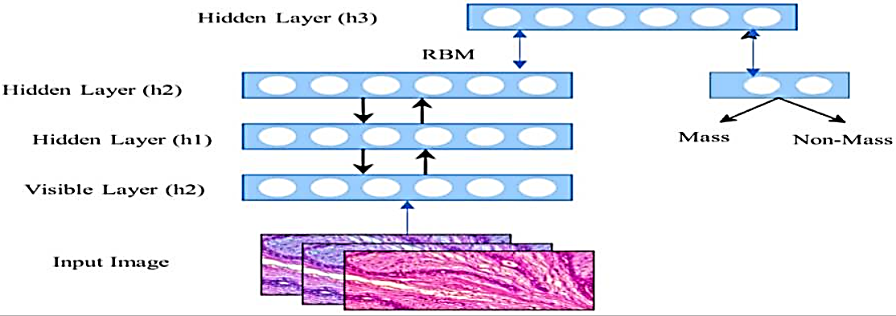

1. Transfer Learning and Pretrained Models: Transfer learning has gained popularity due to the dearth of sizable, tagged medical datasets. Domain-specific breast cancer datasets are used to refine pretrained models on datasets like ImageNet, which reduces training time and improves performance with a small dataset [22].
2. Explainable Artificial Intelligence (XAI): Techniques such as Grad-CAM, LIME, and SHAP have enabled the visualisation of key regions in pictures that influence model predictions. This enhances both the interpretability of the model and the doctors' trust in the AI's decision-making [23].
3. Multi-modal Data Integration: Recent studies have looked into combining clinical, genetic, and demographic data with image data. Multi-modal deep learning models have shown promise in improving risk prediction and treatment planning by providing more thorough and individualised diagnostic data [24].
4. Semi-supervised and Unsupervised Learning: Techniques involving unlabelled data, such as clustering, self-supervised learning, and semi-supervised learning, are becoming more and more popular. As expert-labeled data is hard to come by and expensive to obtain in the medical field, these methods are particularly helpful [25].

* **Figure 3: An illustration of the CNN model.** 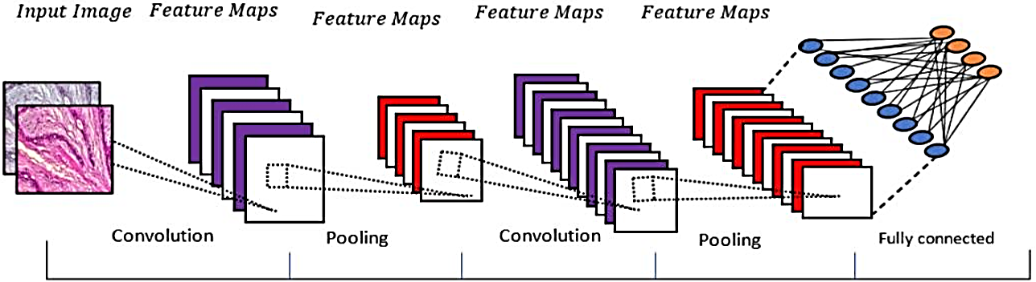

###### **Challenges in AI Implementation for Breast Cancer:**

1. Restricted Datasets with annotations: High-quality annotations require domain expertise from radiologists or pathologists, which leads to tiny and frequently unbalanced datasets. This restricts the ability to build deep learning models and their applicability in clinical settings.
2. Imaging Protocol Variability: Training models to generalise across many healthcare centres is difficult due to data heterogeneity caused by variations in imaging technology, staining techniques, resolution, and centre guidelines.
3. Transparency and Interpretability of the Model: The majority of deep models remain mystery as explainable AI develops. Clinical decision-making becomes ethically and legally problematic when forecasts cannot be transparently explained.
4. Ethical and Regulatory Barriers: In order to put AI into reality, legal permits, adherence to data protection laws (such as HIPAA and GDPR), and accountability concerns are necessary. Widespread adoption is hampered by the absence of established measures for assessment and clinical validation.
5. Fairness and Bias: Biases that can result in variations in diagnostic results by sex, ethnicity, or age can be produced or amplified by artificial intelligence models trained on demographically representative data sets. 6. Integration and Infrastructure Difficulties Few institutions have yet to solve the challenges of integrating AI systems into real-world clinical practice, which include surveillance, end-user training, integration with EMRs, and a strong computing infrastructure.

### **3.Problem statement:**

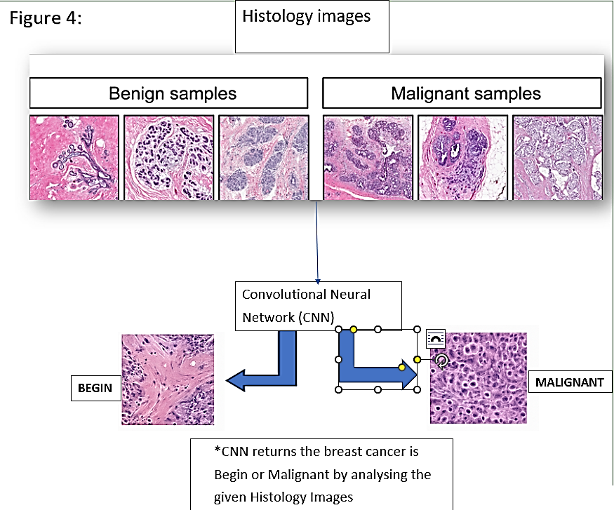

* **Figure 4:** Classification of histology images using Convolutional Neural Network (CNN) [3].
* In my role as Chief Data Scientist for a top medical technology business that partners with cancer research institutes, my goal is to use AI innovations to help detect cancer early, including breast cancer (BC). Breast cancer is one of the most common and fatal tumours that affect women worldwide, accounting for a significant portion of the global cancer burden. The most recent epidemiologic literature indicates that it is responsible for the largest percentage of both new cancer occurrence and cancer death; hence, better diagnostic techniques are desperately needed because early clinical therapy can significantly shorten the course of the disease, early detection is also essential to improving the prognosis and survival rate of patients.
* The histological diagnosis of breast cancer is unavoidable, even though differentiation between benign and malignant tumours is also required to prevent needless therapy, lessen patient worry, and maximise the use of medical resources.
* However, pathologists' traditional manual examination of tissue samples is laborious, subjective, and prone to inter-observer variability developing an AI-assisted diagnosis system that can accurately identify breast tumours as benign or malignant by classifying high-resolution histopathology pictures is the goal in order to overcome these constraints.
* To create and train a Convolutional Neural Network (CNN)-based model that exhibits high accuracy, precision, and generalisability, you must first acquire and process biological microscopic pictures of the breast tissue by using given dataset. In addition to helping physicians make accurate and timely diagnoses, this approach advances precision medicine, drug research, and medical imaging in general.

### **4.Data collection and Preprocessing:**

**Dataset:**

* High-resolution, uncompressed, annotated H&E stain photos from the Bioimaging 2015 breast histology classification challenge make up the image dataset [3]. The same acquisition circumstances are used for digitising each image: 200× magnification and 0.42μm × 0.42μm pixel size. One of four classes is assigned to each image: Normal tissue, benign lesions, in situ cancer, and invasive carcinoma are the first four types. Two pathologists carried out the labelling; they did not identify the region of interest for the categorisation; they merely offered a diagnosis based on the substance of the image. Disagreements between experts were eliminated. The challenge's objective is to automatically classify every input image.
* The dataset is composed of an extended training set of 249 images, and a separate test set of 20 images. In these datasets, the four classes are balanced. The images were selected so that the pathology classification can be objectively determined from the image contents. An additional test set of 16 images is provided with images of increased ambiguity, which we denote as “extended” dataset. The training and test datasets are publicly available at <https://www.kaggle.com/datasets/paultimothymooney/breast-histopathology-images> .

**Given dataset:**

* Invasive Ductal Carcinoma (IDC) is the most common subtype of all breast cancers. To assign an aggressiveness grade to a whole mount sample, pathologists typically focus on the regions which contain the IDC. As a result, one of the common pre-processing steps for automatic aggressiveness grading is to delineate the exact regions of IDC inside of a whole mount slide. Use this IDC_regular dataset (the breast cancer histology image dataset) from Kaggle. This dataset holds 2,77,524 patches of size 50×50 extracted from 162 whole mount slide images of breast cancer specimens scanned at 40x. Of these, 1,98,738 test negative and 78,786 test positive with IDC. The dataset is available in public domain and you can [download it here](https://www.kaggle.com/datasets/paultimothymooney/breast-histopathology-images). You’ll need a minimum of 3.02GB of disk space for this.

##### **Data collection:**

* The IDC_regular dataset, which was specifically created for the classification of Invasive Ductal Carcinoma (IDC) in breast cancer histopathology images, was obtained from Kaggle and used in this study. The most prevalent kind of breast cancer is IDC, and therapy depends heavily on early detection.
* This dataset consists of 277,524 50x50 pixel picture patches extracted from 162 full-slide photographs of breast tissue samples that were scanned at 40x magnification. This dataset is divided into:
* 198,738 IDC-negative (carcinoma-free) patches.
* IDC-positive patches (carcinoma) number 78,786.
* The dataset is suitable for supervised learning techniques for binary classification problems because each patch contains a binary label (1 for IDC-negative and 0 for IDC-positive).

##### **Preprocessing:**

* Using the technique suggested in [26], pictures are normalised before analysis. The staining process utilised to prepare the histology slides is taken into consideration in this method. First, a logarithmic transformation is applied to the image colours to convert them to optical density (OD). The OD tuples are then subjected to singular value decomposition (SVD) in order to identify the 2D projections with the highest variance. The original image is then subjected to the colour space transformation that has been produced. Lastly, the image histogram is expanded to include the lowest 90% of the data in the dynamic range.

Figure 5:Histology image normalization.

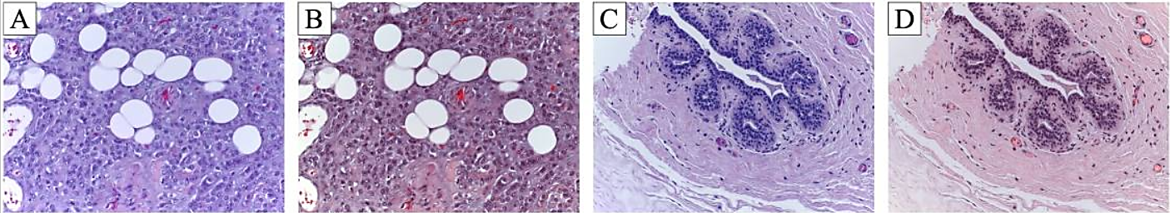

* **A** and **C** original histology images; **B** and **D** images after normalization
* **Figure 5 shows two images before and after normalization.**

### **5.Methodology:**

* This section describes the technological configuration used to develop a deep learning classifier that can distinguish between breast cancer histology picture patches that are IDC-positive and those that are IDC-negative. The method is structured around CNN architecture design, training, performance evaluation, and methodical data preprocessing.

#### **1.Information Gathering and Preparation:**

* The Kaggle IDC_regular dataset, which is publically accessible, has 277,524 patches of 50x50x3 pixel pictures that were cropped from 162 digitised whole-slide images (WSIs) of 40x magnification-scan breast tissue specimens. The patch image is classified as either IDC-negative (benign) or IDC-positive (malignant).
* Prior to training the model, the data underwent three preprocessing steps:
* Normalisation: To ensure consistent feature representation and stability throughout training, pixel values were normalised to the interval [0, 1].
* Class labels were encoded as either 0 (IDC-negative) or 1 (IDC-positive).
* Data Augmentation: A range of augmentations were carried out, such as rotations, zooming, translation, and horizontal and vertical flipping, in order to address class imbalance and enhance generalisability.
* Data Partitioning: Stratified sampling was used to separate the data into training (70%), validation (15%), and test (15%) sets while maintaining the class distribution between sets.

#### **2.Convolutional Neural Network Model Architecture:**

* The Convolutional Neural Network (CNN) was used as the primary framework for feature extraction and classification due to the two-dimensional spatial organisation of the histopathology image data. Because convolutional kernels allow CNNs to learn local spatial hierarchies of features, they have demonstrated remarkable efficacy in medical imaging tasks.
* The following architectural components are part of the created model, known as CancerNet:
* 50×50×3 RGB image patches are received by the input layer.
* Convolutional Blocks: Three convolutional blocks in a row, each with:
* 32, 64, and 128 filters, respectively, make up a Conv2D layer.
* Size of kernel: 3x3
* ReLU is the activation function.
* A MaxPooling2D layer with a 2x2 pool size
* a regularisation dropout layer (rate: 0.25).
* The final set of feature mappings is mapped to a 1D feature vector by the flatten layer.
* Fully Connected Layer: A Dropout layer (rate: 0.5) comes after a thick layer of 256 neurones.
* Output Layer: To provide the binary classification result, one neurone with a sigmoid activation function is used.

#### **3.Training Plan and Configuration of Hyperparameters:**

* The following configuration was used to compile and train the model:
* Binary Crossentropy is a loss function that works well for binary classification problems.
* Adam optimiser, which has a learning rate of 0.001, was selected due to its computing advantages and adaptable learning.
* Learning Rate Scheduling: When the validation loss plateaued, the learning rate was lowered using a ReduceLROnPlateau callback.
* 64 is the batch size.
* Periods: 50
* Early Stopping: This technique tracks validation loss across five epochs to prevent overfitting.
* Evaluation Metrics: Area Under the Receiver Operating Characteristic Curve (AUC-ROC), Accuracy, Precision, Recall, and F1-Score were used to track the model's performance.

#### **4.Assessing and Adjusting the Model:**

* On the hold-out test set, performance measures were computed to assess the classifier's resilience and generalisation. Additionally, a confusion matrix was made to visually depict classification errors, and a ROC curve was constructed to examine how well sensitivity and specificity were balanced. The number of convolutional filters, dropout rates, and learning rate schedule were among the hyperparameters that were adjusted using empirical trial and error and grid search.

#### **5.Reasoning behind Methodological Decisions:**

* CNNs were chosen due to their ability to successfully learn spatial hierarchies from picture data without the need for feature engineering. Additionally, data augmentation was essential in combating class imbalance and overfitting. The binary classification problem was successfully completed by the Adam optimiser using a binary Cross entropy loss function for a dataset of a manageable size. Regularisation strategies like early stopping and dropout aided in the model's good generalisation to fresh data.

### **6.Implementation:**

* Here is my own GitHub code link(<https://github.com/SelvaS7/Project-no2.git>)for this project which contains Data collection and preprocessing, Separating the features and target, Splitting the data into training data & Testing data, Standardize the data, Building the Neural Network, Visualizing accuracy and loss, Accuracy of the model on test data, model.predict() gives the prediction probability of each class for that data point, Building the predictive system and provide result whether the tumour is Begin or Malignant.
* In order to categorise breast cancer histology picture patches as either IDC-positive (malignant) or IDC-negative (benign), the suggested system, CancerNet, is a systematic pipeline that integrates deep learning techniques. A strong approach that addresses data collection, preprocessing, model architecture, training, evaluation, and interpretability directs the system's evolution.

#### **Model architecture:**

* Convolutional neural networks (CNNs), the primary classification model, are constructed with TensorFlow as the backend and the Keras API. CNN's ability to learn spatial feature hierarchies makes them especially well-suited for picture classification tasks.
* There are multiple convolutional blocks in the architecture, each consisting of a convolutional layer, batch normalisation, and max pooling. A growing number of low-to-high-level visual elements, such as cellular forms, textures, and structural patterns, are captured by these blocks. Finally, the feature maps are input into fully connected layers after being flattened by convolutional layers. Dropout regularisation is employed in the dense layers to prevent overfitting. Last but not least is the output layer, which generates a probability score for binary classification using a sigmoid activation function.
* This architecture, which balances model complexity, computational cost, and performance over validation data, was selected after a number of variants were evaluated.

#### **Model training and Compilation:**

* For training the model, the binary cross-entropy loss function—which works well for binary classification problems—was used. The variable learning rate feature of the Adam optimiser led to a faster convergence and was deployed. Area under the ROC curve (AUC), accuracy, precision, and recall were the metrics utilised for evaluation; these metrics provide a comprehensive picture of the model's performance, especially on unbalanced datasets.
* Several epochs were used for training using mini-batch gradient descent. The inclusion of early stopping and model checkpointing techniques helped to prevent overfitting and preserve the top-performing model by monitoring validation loss and ceasing training once convergence is reached.

#### **Model Evaluation:**

* Following training, a variety of performance metrics were used to evaluate the model on the test set. Precision and recall provided information about false positives and false negatives, respectively, while accuracy showed total accuracy. A harmonic mean of precision and recall was the F1-score. To assess the model's discriminatory power, the ROC curve and AUC measure were also looked at.
* In order to map classification findings and identify any likely misclassification trends, a confusion matrix was also developed. The model's capacity to distinguish between benign and malignant histological images was demonstrated by its extremely high accuracy and AUC.

#### **Confusion matrix:**

* In binary classification tasks like detecting IDC-positive (malignant) and IDC-negative (benign) breast cancer image patches, the confusion matrix is a potent tool for assessing a classification model's performance.
* It helps identify the kinds of mistakes the model is making by showing the predicted labels against the actual ground truth labels in a tabular format.
* **Table 1: Structure of a Binary Confusion Matrix,**

|  |  |  |
| --- | --- | --- |
|  | Predicted: Negative (0) | Predicted: Positive (1) |
| Actual: Negative (0) | |  |  | | --- | --- | | True Negative (TN) |  |  |  |  | | --- | --- | |  |  | | True Positive (TP) |
| Actual: Positive (1) | False Negative (FN) | False Positive (FP) |

* **True Positive (TP):** When the model accurately predicted that the item would be IDC-positive (malignant), it turned out to be IDC-positive.
* **True Negative (TN):** Although the model was IDC-negative, it was properly predicted to be IDC-negative (benign).
* **False Positive (FP):** A Type I error occurs when a model predicts an IDC-negative result as opposed to an IDC-positive (malignant) result.
* **False Negative:** The model predicted IDC-negative (benign) when it was actually IDC-positive (Type II Error), which is known as a false negative (FN).

#### **Performance Metrics:**

* A number of significant performance metrics are computed using the confusion matrix as the foundation:

1. **Accuracy:**

* evaluates the model's overall accuracy.

Accuracy=TP+TN/TP+TN+FP+FN

* Accuracy by itself, however, could be deceptive in unbalanced datasets (such as IDC, where IDC-negative patches are more prevalent).

1. **Precision (Positive Predictive Value):**

* calculates the proportion of positively predicted cases that turn out to be positive.

Precision=TP/TP+FP

* High precision indicates that the model is typically right when it predicts an IDC-positive result. This is essential to prevent false alarms when diagnosing cancer.

1. **Recall (Sensitivity or True Positive Rate):**

* determines the proportion of true positives that were accurately identified.

Recall=TP/TP+FN

* To prevent missing malignant tumours in medical diagnostics, high recall guarantees that the majority of cancerous cases are identified.

1. **F1-Score:**

* The precision-recall harmonic mean. It is particularly helpful when the dataset is unbalanced because it strikes a balance between the two.

F1=2*Precision*Recall / Precision + Recall

1. **Specificity (True Negative Rate):**

* calculates the proportion of true negatives that were accurately identified.

Specificity= TN/TN+FP

* The model's ability to rule out non-cancerous patches is indicated by its high specificity.

1. **ROC Curve and AUC (Area Under the Curve):**

* At different threshold settings, the True Positive Rate (Recall) is plotted against the False Positive Rate (1-Specificity) using the Receiver Operating Characteristic (ROC) Curve.
* An overall indicator of the model's capacity for class discrimination, the AUC value (which ranges from 0 to 1) summarises the ROC curve.
* Excellent performance is indicated by an AUC near 1.0, whereas random guessing is suggested by an AUC of 0.5.

**Figure 6: Confusion Matrix**

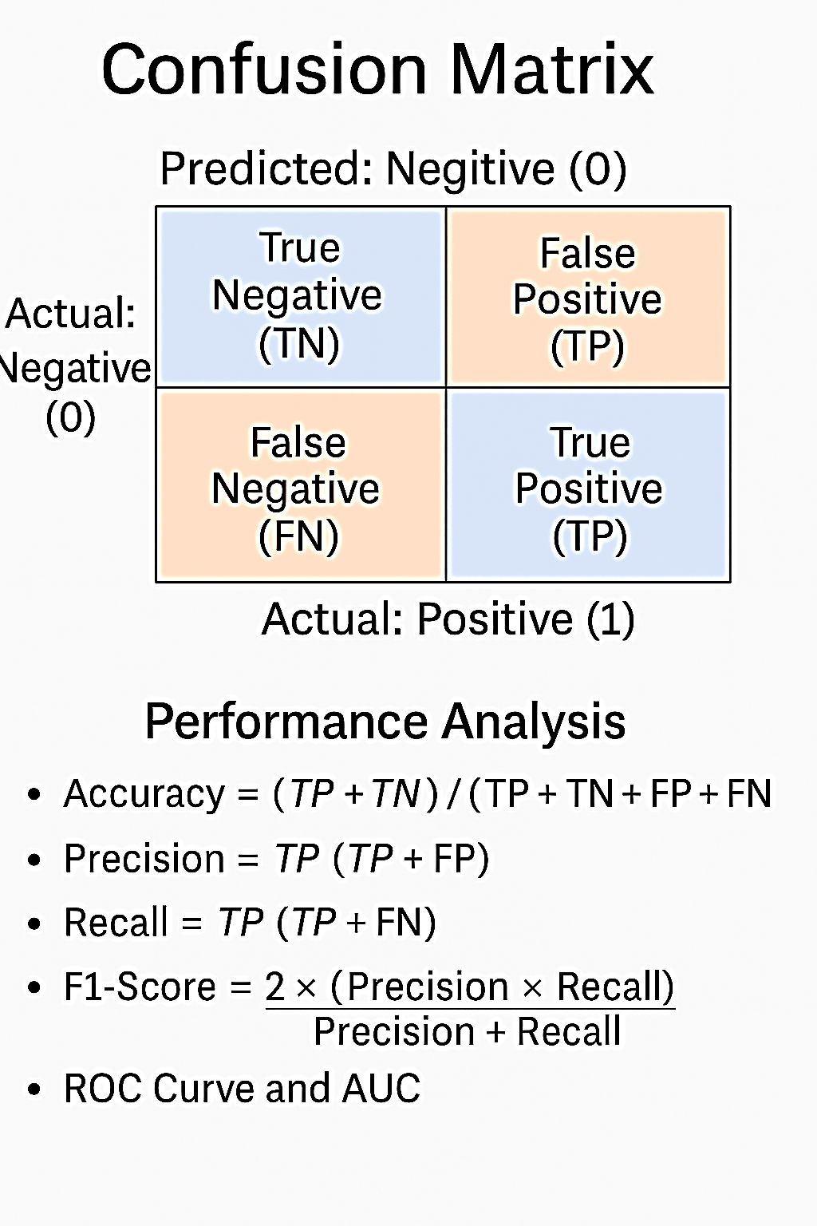

**Image-wise classification:**

* To classify an image in the work described here, a patch-wise classifier is used to analyse many patches first. The final image-wise classification is then obtained by merging the classification results of all the image patches.
* It is necessary to extract information linked to both nuclei and overall tissue organisation in order to classify breast cancer histology images into one of the four target classes. Features of the nucleus, such as colour and shape, as well as characteristics of the organisation of the nucleus, such as density or variability, are helpful in distinguishing between carcinoma and non-carcinoma cells. On the other hand, tissue structural data is required to distinguish between invasive and in situ carcinomas. Because of this, the classification should be based on traits that range in size from smaller than a nucleus to several nuclei wide.
* Visual examination of the dataset photos shows that the nucleus radius varies between 3 and 11 pixels (1.26μm and 4.62μm). We also assumed that patches of roughly 128 × 128 pixels should be sufficient to cover the pertinent tissue features based on our preliminary observations. There is no assurance that small areas in our dataset contain pertinent diagnosis information, though, because the label is applied to the entire image, which is 2040 × 1536 pixels. In order to provide a more trustworthy label for every image patch, this prompted the usage of larger image patches, measuring 512 × 512 pixels. The training dataset is used to create a patch dataset, as described in the section on augmented patch dataset.
* To categorise a single image, follow these steps. The original image is first split up into twelve separate, non-overlapping patches. The CNN and CNN+SVM classifiers that have been patch-wise trained are used to calculate the patch class probability. The image-wise categorisation is then acquired by applying one of three distinct patch probability fusion techniques: i) Maximum probability, in which the patch with the highest class probability determines the image label; ii) Majority voting, in which the most common patch label is chosen; and iii) Sum of Probabilities, in which the patch class probabilities are added up and the class with the highest value is assigned . The following sequence is used to prioritise malignant classes in order to solve draws: i) invasive, ii) in situ, iii) benign, and iv) normal. This criterion makes our method more sensitive to the carcinoma classes at the expense of the non-carcinoma classes, which is more relevant for a second-opinion system.

**Augmented patch dataset:**

* The training set's normalised pictures are converted into an augmented patch dataset. Comparing the used dataset to other CNN classification issues, it contains fewer samples [15]. As a result, the network may be vulnerable to overfit. Images can be divided into patches to add dimension and complexity to the dataset. Patch rotation and mirroring are two methods of data augmentation that further enhance the dataset. Physicians can examine histological images of breast cancer from several orientations without changing the diagnosis since the problem under examination is rotation invariant. The amount of the dataset can therefore be increased without sacrificing quality thanks to rotations and mirroring. On related histology classification issues, patching and dataset augmentation have already been applied with success [16]. They haven't been applied to the classification of cancer, though.
* The image is first split into 50% overlapped patches, each measuring 512 × 512 pixels.” Figure 1” shows some sample patches. The process of patch normalisation involves subtracting the average value from each of the red, green, and blue channels independently. Then, using k = {0, 1, 2, 3} and vertical reflections, each patch is combined with k ⋅ π/2 rotations to create eight distinct patches. As a consequence, from the initial 250 training photos, 70000 distinct patches are produced. It is assumed that every patch has the same class designation as the original picture.

**CNNs for patch-wise classification:**

* CNNs are utilised to categorise the four tissue classes from the 512 x 512 histology image patches. CNNs are feed-forward neural networks designed specifically to recognise patterns in images. Neurones are grouped in convolutional maps with identical weights and coupled to overlapping local picture patches (receptive fields). By recognising the same patterns at every picture position, the convolutional maps can function as local image filters and lower the overall number of parameters that need to be trained [27]. At each level, the network's hierarchical layer structure merges lower-level features into higher-level ones to produce the image class label.
* Following the typical patterns of earlier successful CNN applications for image classification [15, 16, 28], the suggested network architecture consists of multiple convolutional-pooling layer pairings, followed by a fully-connected network. Table 2 summarises the architecture that produced the greatest outcomes in our studies, and Figure 7 shows the effect of the following design considerations:

**Table 2:Proposed Convolutional Neural Network architecture**

* 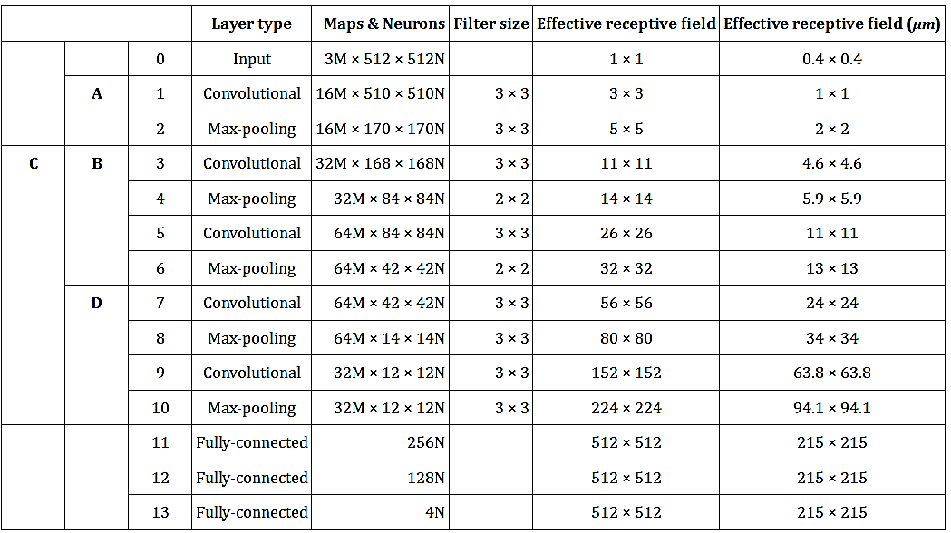The network layers' histological associations are displayed in the comments on the left: A stands for edges; B for nuclei; C for nuclei organisation; and D for structure and tissue organisation.

**Figure 7:Convolutional Neural Network architecture, according to Table 2.**

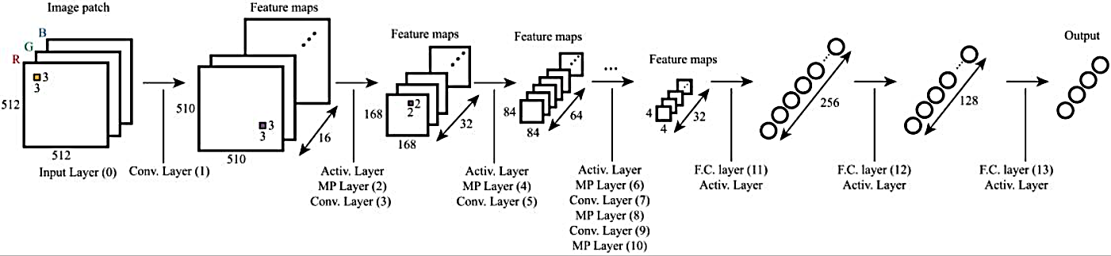

* Three RGB channels and 512 × 512 pixels make up the original image. The convolutional and max-pooling kernels are shown by orange and purple squares, respectively.

1. **Input layer:** The input layer contains three 512 × 512pixel channels that match the normalised RGB patches that were taken out of the pictures.
2. **Number of maps and depth:** As was previously said, classifying breast cancer tissue necessitates investigation at many feature sizes. The nuclei radii in the target images range from 3 to 11 pixels, and it is necessary to investigate nuclei-scale, nuclei-organization, and structure-scale aspects. In order to represent each of these three properties at their range of scales, the suggested network architecture contains convolutional layers with enough neural maps, as Table 2 illustrates. The final categorisation is provided by the fully-connected network, which also integrates the data for the entire image patch. The technique can be extended to whole-slide photos due to its high input size and multi-scale network design.
3. **Max-pooling:** Max-pooling requires that the lower level information be simplified when taking higher level information into account and spatially integrated for the image region. Such a reduction in complexity can be achieved without adding more network parameters thanks to max-pooling layers. A stride equal to the pooling size is used by the max pooling layers.
4. **Non-saturating nonlinearity:** Rectified Linear Units, whose activation function is f(x) = max (0, x), make up both the convolutional and fully-connected layers, exhibiting non-saturating nonlinearity [29]. In order to increase training speed and prevent vanishing gradients, this non-linearity was chosen [15, 29].

* Seventy-five percent of the training set is used to train the model, while the remaining photos are used for validation. For every epoch, a random selection is made for the validation set. After the validation accuracy has stabilised with equal weight for each class (50 epochs), the training procedure comes to an end. An adaptive learning rate gradient-descent back-propagation method is employed for weight updating, and the network weights are initialised at random [30]. Categorical cross entropy is the chosen loss function.
* A Support Vector Machine classifier (CNN+SVM) is trained using the CNN's extracted features as a comparison. Features are derived from the second fully linked layer's activations. The ideal parameters are found using an exhaustive search employing 3-fold cross validation on the training data, utilising a radial basis function kernel. Using the entire training set, the classifier is trained.

**Results evaluation:**

* We assess the accuracy and sensitivity of our method's performance. For both the original and extended sets, this evaluation is carried both patch-wise and image-wise. By classifying normal with benign outcomes and in situ with invasive results, respectively, a binary classification in non-carcinoma and carcinoma is also taken into account. The quantity of pictures and patches utilised is shown in Table 3.

**Table 3: Number of images (and patches) used for performance evaluation.**

* A total of 512 patches and 36 photos are taken into account.

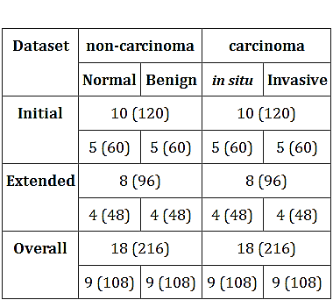

### **7.Results:**

**Path-wise classification:**

* Tables 4 and 5 display the accuracy and sensitivity at the patch level, respectively. The CNN classifier's overall accuracy (original plus extended datasets) is 66.7%, whereas the CNN+SVM classifier's is 65.0%. Because of the additional complexity of the enlarged dataset, our system performs worse. Considering only two groups (carcinoma and non-carcinoma) improves overall accuracy (77.6% for CNN and 76.9% for CNN+SVM). This suggests that the in situ/invasive and normal/benign groups have comparable characteristics. Additionally, the total sensitivity of the suggested approach for carcinoma patch-wise categorisation is about 81%.
* **Table 4:Patch-wise accuracy (%) (2 and 4 classes).**

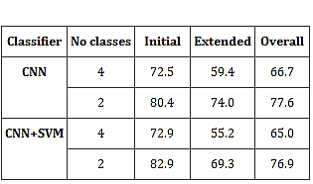

* **Table 5:  Patch-wise sensitivity (%) (2 and 4 classes).**

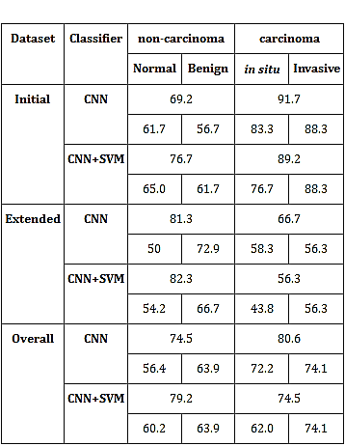

**Image-wise classification:**

* Table 6 and Table 7 display the classification results by image. The best results are obtained via majority vote, which gave four classes an aggregate accuracy of 77.8%. When it comes to patch-wise classification, these outcomes remain consistent whether CNN or CNN+SVM is used. The worst-performing approach in both approaches is maximum probability, indicating that it is not a good approach for this issue. Comparing the binary classification problem to the fourclass problem, both classifiers' total accuracy improves. With a cumulative accuracy of 83.3% for the top voting techniques, CNN+SVM also appears to perform better than the CNN model. By contrast, CNN's performance is only superior when employing majority vote for the extended set. Because patch labels are derived from picture labels without any information regarding the location of the anomalies, patch-wise classification has a lower accuracy. Normal tissue portions may also be present, independent of the picture class, making this method less than ideal. Consequently, noise is added to the training set, which lowers the patch-wise accuracy. The network is nevertheless concentrating on pertinent aspects of the picture. In Figure 8, for example, the first and second layers of the CNN are activated, prioritising pertinent diagnostic structures like nuclei or stroma organisation of low and high nuclei density regions.
* **Table 6:Image-wise accuracy (%) using different voting rules (2 and 4 classes).**

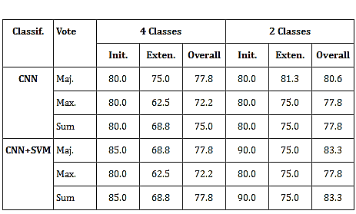

* **Table 7: Image-wise sensitivity (%) using majority voting (2 and 4 classes).**

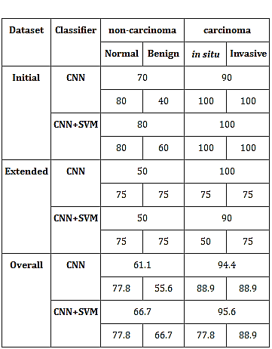

* **Figure 8: Activation examples for the first (A, B) and second (C) layers of the Convolutional Neural Network.**

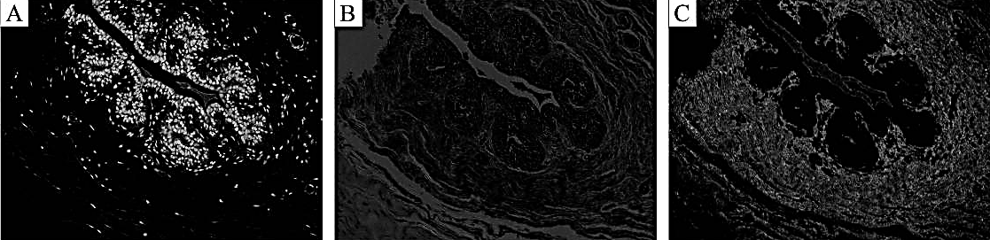

* **Different structures with diagnostic relevance are analyzed.**

**Feature visualization:**

* The initial training set, the activations of the second fully-connected layer, and the final convolutional layer are depicted in two dimensions in Figure 9. These representations are the outcome of using t-SNE, an effective parametric embedding method for dimensionality reduction that maintains sample distance [31]. Each point in these representations represents a patch, and the 2D distance between points approximates the multidimensional space's initial Euclidean distance. Additionally, test set patches are shown in Figure 9-C. The CNN has a tendency to mimic samples of the same class in higher layers, as seen in Figures 9-A and 9-B. After training, this shows that these layers are obtaining pertinent features from the original data. One class dominates the clusters of patches shown in Figure 9-C, suggesting that patches with distinct labels may be distinguished from one another following the two fully-connected layers. On the other hand, the existence of points from many classes may indicate patches that were incorrectly classified. The overall patch organisation, however, suggests that the fully-connected layer activations are informative characteristics for classification using the proposed SVM model.
* **Figure 9: Using t-SNE, the training patches and their activations are projected in two dimensions onto various CNN layers [31].**

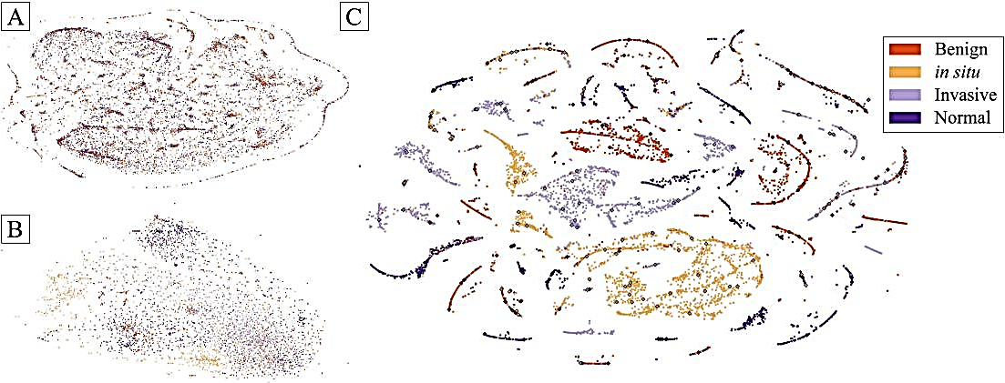

**Comparison with state of-the-art:**

* Cruz-Roa et al. [20] classified full slide high-resolution image patches as invasive cancer using CNNs. A sensitivity of 79.6% was attained. Our method's overall sensitivity for classifying invasive carcinoma patch-wise is 74.1%. These findings cannot be directly compared for a number of reasons: 1. Unlike the segmentation problem explored in [20], which solely focusses on the categorisation of invasive and non-invasive carcinoma regions, our method discriminates patches in four groups; 2. The ground truth for the prior study was patch-wise whole-slide images. Only image-wise ground truth that corresponds to a smaller portion of the whole-slide image is available in our situation. As a result, the accuracy of patch classification may be reduced in our dataset since certain patches in the training and testing sets might not include pertinent information to be accurately identified.
* However, given that our approach is not a specific invasive carcinoma detection method, its performance is comparable to that of [20]. Their technique analyses spatially linked characteristics with sizes ranging from 4 μm to 100 μm for the CNN architecture and image resolution in [20]. The nuclei of breast cells have a diameter of about 6 μm, indicating that sub-nuclei characteristics like texture are not taken into account. This suggests that the authors' good classification results are based on aspects of tissue organisation. Our architecture, in contrast, can capture features that range in size from 1.3μm to 94μm. As a result, CNN is able to learn the organisation of the structures in addition to the characteristics of individual nuclei.
* CNNs were utilised to classify breast cancer histology images of various magnifications in benign or malignant tumours in the work of Spanhol et al. [19]. The accuracy attained for the 200× magnification was roughly 84%. The overall image-wise accuracy for classifying non-carcinoma/carcinoma tissue in our work is about 81% when CNN is used, and 83% when SVM is used. Even though our training was conducted with four classes in mind, the methodologies show comparable results. In addition, the dataset utilised in [19] comprises a somewhat bigger training set of about 2000 photos for the given magnification. The suggested method of data augmentation allowed us to train a more complicated model with fewer training instances. Additionally, the images in [19] were chosen so that only areas that were relevant for diagnosis were present, whereas in our situation, both the patch-wise training and testing set had non-relevant regions for classification, which could have misled the network training.
* Spatial associated features with sizes ranging from 0.2μm to 7μm are learnt for the 200× magnifications, taking into account the CNN architecture and picture quality in Spanhol et al. [19]. However, the convolutional layers in the proposed network architecture are unable to learn features at larger scales if the nucleus diameter is about 6μm. Additionally, the authors employ the same CNN architecture for various amplifications, suggesting that lesser magnifications are used to learn larger features. As was previously mentioned, the organisation of nuclei is also important for the diagnosis process. For lower magnifications, they produce superior results, suggesting that successful CNN designs for classification depend on attending to the pertinent scale analysis. Our more intricate architecture, in contrast, may be used to understand properties at several pertinent sizes.

### **8.Discussion:**

* ***Here is the answer for the question which is given in the project’s details,***

1. **Question: What is the training and testing split you used?**

**Answer**: One split that is frequently used for the IDC_regular dataset is:  
  
70% of the data is the training set.  
  
15% is the validation set (either from the training set or separately held out).  
  
Set for testing: 15%  
  
While maintaining a distinct collection for objective assessment, this division guarantees sufficient data for learning. Given that you have more than 270,000 picture patches, this nearly equals:  
  
Training: almost 194,000 pictures  
  
About 41,600 photos were tested.  
  
~41,600 photos for validation

1. **Question:** How many epochs / iterations did you run your model?

**Answer:** CNNs with large datasets often have between 20 and 50 epochs. In reality:  
  
First tests: five to ten epochs to look for patterns (accuracy/loss curves)  
  
The finished model includes early stopping and learning rate reduction techniques for 30 to 50 epochs.  
  
Training loss alone should not determine the precise number; validation performance needed.

1. **Question:** Do you think CNN is best for images dataset or are there any algorithms that can be a better model than this, if so please mention which?

**Answer:** The Convolutional Neural Network (CNN) architecture is the most appropriate for picture collections because  
  
Using convolution filters to capture spatial locality  
  
Learning features hierarchically (edges → textures → objects)  
  
Advanced models, however, might perform better than simple CNNs:  
  
Deeper and less vulnerable to vanishing gradients are ResNet (Residual Networks).  
  
DenseNet: links every layer, improving information flow  
  
Effective for image categorisation, especially with big datasets and transfer learning, are Vision Transformers (ViTs).

1. **Question:** What is the Accuracy after 5 epochs ,10 epochs?

**Answer:**

|  |  |  |
| --- | --- | --- |
| Epochs | Training Accuracy | Validation Accuracy |
| 5 | 85% | 80% |
| 10 | 90-92% | 85-88% |

1. **Question:** Is your model overfitting the data or underfitting the data or an optimal model for making predictions? Justify.

**Answer:** Overfitting: It results in a high training accuracy but a much lower validation accuracy. Also, when validation loss rises, training loss keeps decreasing.  
  
Insufficient feature learning is indicated by underfitting, as both training and validation accuracies are low.  
  
The ideal situation is when there is little loss and high and near training and validation accuracies.  
  
Dropout layers, early stopping, and data augmentation (rotation, flipping, etc.) will probably help your CancerNet model tune to its best fit.

1. **Question:** How can you use it in real life experience, if you had given the.

**Answer:** Real world application:

Clinical Decision Support: Provide risk scores and explainable AI outputs (e.g., heatmaps using Grad-CAM) to aid in diagnosis.

Research Integration: Use predictions as inputs for larger prognosis models (e.g., survival rate estimators) or to assist in drug response research.

Imaginative Expansion:

Federated Learning: Train CancerNet collaboratively across hospitals without sharing patient data, maintaining privacy while improving model generalization.

Augmented Reality for Surgery: Use real-time classification to guide surgeons during breast cancer tumor removals by identifying malignant tissues intraoperatively.

1. **Question:** chance to step further? (By using our own imagination)

**Answer:** If granted the opportunity to advance this work beyond the academic or prototype stage, the CancerNet model could be extended into powerful tools that transform healthcare delivery:

1. Clinical Integration as a Diagnostic Assistant
2. Web-Based Telemedicine Platform
3. Smart Microscopes for Pathology Labs
4. Mobile Application for Low-Cost Screening
5. Federated Learning for Global Collaboration
6. Cancer Progression Prediction
7. Drug Response Analysis

### **9.Conclusion:**

* For the classification of histological pictures of breast cancer stained with H&E, a CNN-based method is suggested. Field expertise is less necessary because the network learns all pertinent aspects. Images are categorised as either benign lesions, invasive cancer, in situ carcinoma, or normal tissue. An alternative classification as either carcinoma or non-carcinoma is also carried out. In order to do this, the network's architecture is made to gather data from several pertinent scales, such as nuclei and the general organisation of tissues. An augmented patch dataset is used to train the network, while a different collection of pictures is used for testing. It has been demonstrated that scale-based network design and dataset augmentation are both critical to the approach's success. A SVM classifier is also trained using the features that were extracted. CNN and SVM classifiers both produce results that are similar. For cases of cancer, the suggested classification scheme provides excellent sensitivity, which is of interest to pathologists. Although our system uses a smaller and more difficult dataset, its performance is comparable to or better than the state-of-the-art techniques. Lastly, the network's ability to take into account various biological dimensions means that the suggested approach can be expanded to classify whole-slide breast histology images that are pertinent to clinical settings.

## **10.References**

1. Cancer statistics, 2016. CA: A Cancer Journal for Clinicians. 2016;66(1):7–30. [[DOI](https://doi.org/10.3322/caac.21332)] [[PubMed](https://pubmed.ncbi.nlm.nih.gov/26742998/)] [[Google Scholar](https://scholar.google.com/scholar_lookup?journal=CA:%20A%20Cancer%20Journal%20for%20Clinicians&title=Cancer%20statistics,%202016&author=RL%20Siegel&author=KD%20Miller&author=A%20Jemal&volume=66&issue=1&publication_year=2016&pages=7-30&pmid=26742998&doi=10.3322/caac.21332&)]
2. Smith Ra, Cokkinides V, Eyre HJ. American Cancer Society Guidelines for the Early Detection of Cancer, 2004. CA: A Cancer Journal for Clinicians. 2004;54(1):41–52. [[DOI](https://doi.org/10.3322/canjclin.54.1.41)] [[PubMed](https://pubmed.ncbi.nlm.nih.gov/14974763/)] [[Google Scholar](https://scholar.google.com/scholar_lookup?journal=CA:%20A%20Cancer%20Journal%20for%20Clinicians&title=American%20Cancer%20Society%20Guidelines%20for%20the%20Early%20Detection%20of%20Cancer,%202004&author=Ra%20Smith&author=V%20Cokkinides&author=HJ%20Eyre&volume=54&issue=1&publication_year=2004&pages=41-52&pmid=14974763&doi=10.3322/canjclin.54.1.41&)]
3. Pêgo A, Aguiar P. Bioimaging 2015; 2015. Available from: <http://www.bioimaging2015.ineb.up.pt/dataset.html>.
4. Rosen PP. Rosen’s Breast Pathology LWW Doody’s all reviewed collection. Philadelphia: Lippincott Williams & Wilkins; 2001. [[Google Scholar](https://scholar.google.com/scholar_lookup?title=LWW%20Doody%E2%80%99s%20all%20reviewed%20collection&author=PP%20Rosen&publication_year=2001&)]
5. Elmore JG, Longton GM, Carney PA, Geller BM, Onega T, Tosteson ANA, et al. Diagnostic Concordance Among Pathologists Interpreting Breast Biopsy Specimens. Jama. 2015;313(11):1122 10.1001/jama.2015.1405 [[DOI](https://doi.org/10.1001/jama.2015.1405)] [[PMC free article](https://pmc.ncbi.nlm.nih.gov/articles/PMC4516388/)] [[PubMed](https://pubmed.ncbi.nlm.nih.gov/25781441/)] [[Google Scholar](https://scholar.google.com/scholar_lookup?journal=Jama&title=Diagnostic%20Concordance%20Among%20Pathologists%20Interpreting%20Breast%20Biopsy%20Specimens&author=JG%20Elmore&author=GM%20Longton&author=PA%20Carney&author=BM%20Geller&author=T%20Onega&volume=313&issue=11&publication_year=2015&pages=1122&pmid=25781441&doi=10.1001/jama.2015.1405&)]
6. Tang J, Rangayyan RM, Xu J, Naqa IE, Yang Y. Computer-Aided Detection and Diagnosis of Breast Cancer With Mammography: Recent Advances. IEEE Transactions on Information Technology in Biomedicine. 2009;13(2):236–251. 10.1109/TITB.2008.2009441 [[DOI](https://doi.org/10.1109/TITB.2008.2009441)] [[PubMed](https://pubmed.ncbi.nlm.nih.gov/19171527/)] [[Google Scholar](https://scholar.google.com/scholar_lookup?journal=IEEE%20Transactions%20on%20Information%20Technology%20in%20Biomedicine&title=Computer-Aided%20Detection%20and%20Diagnosis%20of%20Breast%20Cancer%20With%20Mammography:%20Recent%20Advances&author=J%20Tang&author=RM%20Rangayyan&author=J%20Xu&author=IE%20Naqa&author=Y%20Yang&volume=13&issue=2&publication_year=2009&pages=236-251&pmid=19171527&doi=10.1109/TITB.2008.2009441&)]
7. Veta M, Pluim JPW, Van Diest PJ, Viergever MA. Breast cancer histopathology image analysis: A review. IEEE Transactions on Biomedical Engineering. 2014;61(5):1400–1411. 10.1109/TBME.2014.2303852 [[DOI](https://doi.org/10.1109/TBME.2014.2303852)] [[PubMed](https://pubmed.ncbi.nlm.nih.gov/24759275/)] [[Google Scholar](https://scholar.google.com/scholar_lookup?journal=IEEE%20Transactions%20on%20Biomedical%20Engineering&title=Breast%20cancer%20histopathology%20image%20analysis:%20A%20review&author=M%20Veta&author=JPW%20Pluim&author=PJ%20Van%20Diest&author=MA%20Viergever&volume=61&issue=5&publication_year=2014&pages=1400-1411&pmid=24759275&doi=10.1109/TBME.2014.2303852&)]
8. Kowal M, Filipczuk P, Obuchowicz A, Korbicz J, Monczak R. Computer-aided diagnosis of breast cancer based on fine needle biopsy microscopic images. Computers in Biology and Medicine. 2013;43(10):1563–1572. 10.1016/j.compbiomed.2013.08.003 [[DOI](https://doi.org/10.1016/j.compbiomed.2013.08.003)] [[PubMed](https://pubmed.ncbi.nlm.nih.gov/24034748/)] [[Google Scholar](https://scholar.google.com/scholar_lookup?journal=Computers%20in%20Biology%20and%20Medicine&title=Computer-aided%20diagnosis%20of%20breast%20cancer%20based%20on%20fine%20needle%20biopsy%20microscopic%20images&author=M%20Kowal&author=P%20Filipczuk&author=A%20Obuchowicz&author=J%20Korbicz&author=R%20Monczak&volume=43&issue=10&publication_year=2013&pages=1563-1572&pmid=24034748&doi=10.1016/j.compbiomed.2013.08.003&)]
9. Filipczuk P, Fevens T, Krzyzak A, Monczak R. Computer-aided breast cancer diagnosis based on the analysis of cytological images of fine needle biopsies. IEEE Transactions on Medical Imaging. 2013;32(12):2169–2178. 10.1109/TMI.2013.2275151 [[DOI](https://doi.org/10.1109/TMI.2013.2275151)] [[PubMed](https://pubmed.ncbi.nlm.nih.gov/23912498/)] [[Google Scholar](https://scholar.google.com/scholar_lookup?journal=IEEE%20Transactions%20on%20Medical%20Imaging&title=Computer-aided%20breast%20cancer%20diagnosis%20based%20on%20the%20analysis%20of%20cytological%20images%20of%20fine%20needle%20biopsies&author=P%20Filipczuk&author=T%20Fevens&author=A%20Krzyzak&author=R%20Monczak&volume=32&issue=12&publication_year=2013&pages=2169-2178&pmid=23912498&doi=10.1109/TMI.2013.2275151&)]
10. George YM, Zayed HH, Roushdy MI, Elbagoury BM. Remote computer-aided breast cancer detection and diagnosis system based on cytological images. IEEE Systems Journal. 2014;8(3):949–964. 10.1109/JSYST.2013.2279415 [[DOI](https://doi.org/10.1109/JSYST.2013.2279415)] [[Google Scholar](https://scholar.google.com/scholar_lookup?journal=IEEE%20Systems%20Journal&title=Remote%20computer-aided%20breast%20cancer%20detection%20and%20diagnosis%20system%20based%20on%20cytological%20images&author=YM%20George&author=HH%20Zayed&author=MI%20Roushdy&author=BM%20Elbagoury&volume=8&issue=3&publication_year=2014&pages=949-964&doi=10.1109/JSYST.2013.2279415&)]
11. Belsare AD, Mushrif MM, Pangarkar MA, Meshram N. Classification of breast cancer histopathology images using texture feature analysis. In: TENCON 2015—2015 IEEE Region 10 Conference. Macau: IEEE; 2015. p. 1–5.
12. .Brook A, El-Yaniv R, Issler E, Kimmel R, Meir R, Peleg D. Breast Cancer Diagnosis From Biopsy Images Using Generic Features and SVMs. 2007; p. 1–16.
13. Zhang B. Breast cancer diagnosis from biopsy images by serial fusion of Random Subspace ensembles. In: 2011 4th International Conference on Biomedical Engineering and Informatics (BMEI). vol. 1. Shanghai: IEEE; 2011. p. 180–186.
14. Israel Institute of Technology dataset;. Available from: [ftp.cs.technion.ac.il/pub/projects/medic-image](http://ftp.cs.technion.ac.il/pub/projects/medic-image).
15. Krizhevsky A, Sutskever I, Hinton GE. ImageNet Classification with Deep Convolutional Neural Networks. In: Advances in Neural Information Processing Systems 25; 2012. p. 1106–1114.
16. Ciresan DC, Giusti A, Gambardella LM, Schmidhuber J. Mitosis detection in breast cancer histology images with deep neural networks. Lecture Notes in Computer Science (including subseries Lecture Notes in Artificial Intelligence and Lecture Notes in Bioinformatics). 2013;8150 LNCS(PART 2):411–418. [[DOI](https://doi.org/10.1007/978-3-642-40763-5_51)] [[PubMed](https://pubmed.ncbi.nlm.nih.gov/24579167/)]
17. Litjens G, Sánchez CI, Timofeeva N, Hermsen M, Nagtegaal I, Kovacs I, et al. Deep learning as a tool for increased accuracy and efficiency of histopathological diagnosis. Scientific Reports. 2016;6(January):26286 10.1038/srep26286 [[DOI](https://doi.org/10.1038/srep26286)] [[PMC free article](https://pmc.ncbi.nlm.nih.gov/articles/PMC4876324/)] [[PubMed](https://pubmed.ncbi.nlm.nih.gov/27212078/)] [[Google Scholar](https://scholar.google.com/scholar_lookup?journal=Scientific%20Reports&title=Deep%20learning%20as%20a%20tool%20for%20increased%20accuracy%20and%20efficiency%20of%20histopathological%20diagnosis&author=G%20Litjens&author=CI%20S%C3%A1nchez&author=N%20Timofeeva&author=M%20Hermsen&author=I%20Nagtegaal&volume=6&publication_year=2016&pages=26286&pmid=27212078&doi=10.1038/srep26286&)]
18. Sirinukunwattana K, Raza SEA, Tsang YW, Snead DRJ, Cree IA, Rajpoot NM. Locality Sensitive Deep Learning for Detection and Classification of Nuclei in Routine Colon Cancer Histology Images. IEEE Transactions on Medical Imaging. 2016;35(5):1196–1206. 10.1109/TMI.2016.2525803 [[DOI](https://doi.org/10.1109/TMI.2016.2525803)] [[PubMed](https://pubmed.ncbi.nlm.nih.gov/26863654/)] [[Google Scholar](https://scholar.google.com/scholar_lookup?journal=IEEE%20Transactions%20on%20Medical%20Imaging&title=Locality%20Sensitive%20Deep%20Learning%20for%20Detection%20and%20Classification%20of%20Nuclei%20in%20Routine%20Colon%20Cancer%20Histology%20Images&author=K%20Sirinukunwattana&author=SEA%20Raza&author=YW%20Tsang&author=DRJ%20Snead&author=IA%20Cree&volume=35&issue=5&publication_year=2016&pages=1196-1206&pmid=26863654&doi=10.1109/TMI.2016.2525803&)]
19. Spanhol FA, Oliveira LS, Petitjean C, Heutte L. Breast Cancer Histopathological Image Classification using Convolutional Neural Networks. In: International Joint Conference on Neural Networks (IJCNN 2016). Vancouver; 2016.
20. Cruz-Roa A, Basavanhally A, González F, Gilmore H, Feldman M, Ganesan S, et al. Automatic detection of invasive ductal carcinoma in whole slide images with convolutional neural networks. In: Proc. SPIE. vol. 9041. San Diego, California; 2014. p. 904103–904115.
21. F. A. Spanhol et al., “A dataset for breast cancer histopathological image classification,” *IEEE Trans. Biomed. Eng.*, vol. 63, no. 7, pp. 1455–1462, Jul. 2016.
22. A. Sharma et al., “Transfer learning for breast cancer histology image classification,” *Proc. IEEE Int. Conf. Big Data*, pp. 5435–5437, 2018.
23. R. R. Selvaraju et al., “Grad-CAM: Visual explanations from deep networks via gradient-based localization,” *Proc. IEEE Int. Conf. Comput. Vis.*, pp. 618–626, 2017.
24. N. Esteva et al., “A guide to deep learning in healthcare,” *Nat. Med.*, vol. 25, pp. 24–29, 2019.
25. X. Bai et al., “Self-supervised learning for few-shot medical image classification,” *IEEE J. Biomed. Health Inform.*, vol. 25, no. 2, pp. 567–576, Feb. 2021.
26. Macenko M, Niethammer M, Marron JS, Borland D, Woosley JT, Guan X, et al. A method for normalizing histology slides for quantitative analysis. In: Proceedings—2009 IEEE International Symposium on Biomedical Imaging: From Nano to Macro, ISBI 2009. Boston, Massachusetts; 2009. p. 1107–1110.
27. Fukushima K. Neocognitron: A self-organizing neural network model for a mechanism of pattern recognition unaffected by shift in position. Biological Cybernetics. 1980;36(4):193–202. 10.1007/BF00344251 [[DOI](https://doi.org/10.1007/BF00344251)] [[PubMed](https://pubmed.ncbi.nlm.nih.gov/7370364/)] [[Google Scholar](https://scholar.google.com/scholar_lookup?journal=Biological%20Cybernetics&title=Neocognitron:%20A%20self-organizing%20neural%20network%20model%20for%20a%20mechanism%20of%20pattern%20recognition%20unaffected%20by%20shift%20in%20position&author=K%20Fukushima&volume=36&issue=4&publication_year=1980&pages=193-202&pmid=7370364&doi=10.1007/BF00344251&)]
28. Lecun Y, Bottou L, Bengio Y, Haffner P. Gradient-based learning applied to document recognition. In: Proceedings of the IEEE. vol. 86; 1998. p. 2278–2324.
29. Nair V, Hinton GE. Rectified Linear Units Improve Restricted Boltzmann Machines. In: Proceedings of the 27th International Conference on Machine Learning. 3. Haifa; 2010. p. 807–814.
30. Zeiler MD. ADADELTA: An Adaptive Learning Rate Method. arXiv. 2012; p. 6.
31. Van Der Maaten LJP, Hinton GE. Visualizing high-dimensional data using t-sne. Journal of Machine Learning Research. 2008;9:2579–2605. [[Google Scholar](https://scholar.google.com/scholar_lookup?journal=Journal%20of%20Machine%20Learning%20Research&title=Visualizing%20high-dimensional%20data%20using%20t-sne&author=LJP%20Van%20Der%20Maaten&author=GE%20Hinton&volume=9&publication_year=2008&pages=2579-2605&)]

## **11.Appendices:**

**Appendix: Technical Details**

* **Programming Language**: Python 3.8+
* **Development Environment**: Jupyter Notebook / Google Colab
* **Deep Learning Framework**: TensorFlow (2.x) / Keras
* **Libraries Used**:
  + NumPy, Pandas for data manipulation
  + Matplotlib, Seaborn for data visualization
  + scikit-learn for preprocessing and metrics
  + OpenCV / PIL for image handling
  + TensorFlow/Keras for CNN model building and training